1 :Find-S Algorithm Implementation

Training data: [Outlook, Temperature, Humidity, Wind, PlayTennis]
dataset = [
['Sunny', 'Warm', 'Normal', 'Strong', 'Yes'],
['Sunny', 'Warm', 'High', 'Strong', 'Yes'],
['Rainy', 'Cold', 'High', 'Strong', 'No'],
['Sunny', 'Warm', 'High', 'Weak', 'Yes']
]

Step 1: Initialize the hypothesis
hypothesis = ['ϕ'] * (len(dataset[0]) - 1)

Step 2: Find-S algorithm
for sample in dataset:
if sample[-1] == 'Yes': # Only positive examples
for i in range(len(hypothesis)):
if hypothesis[i] == 'ϕ':
hypothesis[i] = sample[i]
elif hypothesis[i] != sample[i]:
hypothesis[i] = '?'

Step 3: Output
print("Final Specific Hypothesis:", hypothesis)

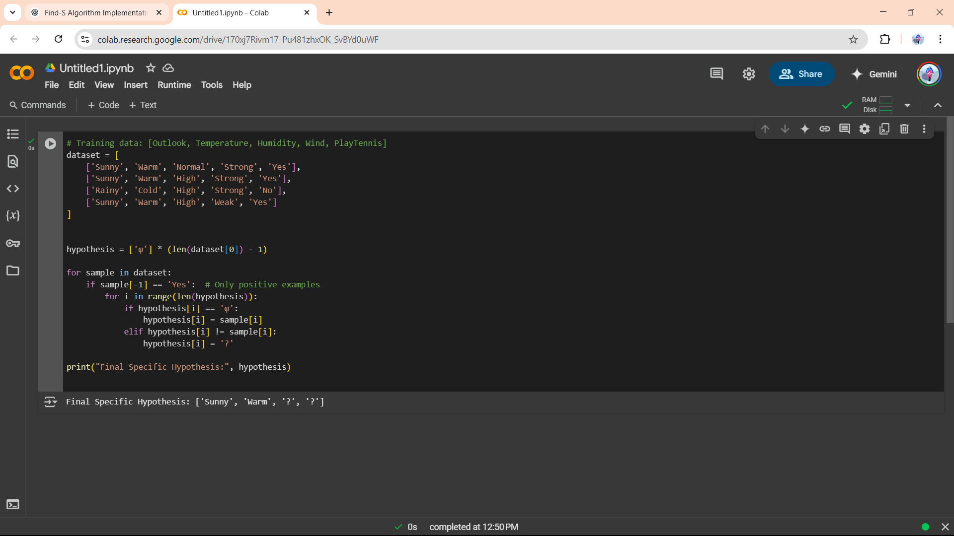
2 :Candidate Elimination Algorithm

Step 1:

import pandas as pd
from google.colab import files

data = pd.read_csv(next(iter(files.upload())))

X, y = data.iloc[:, :-1].values, data.iloc[:, -1].values

S, G = X[0].copy(), [["?" for _ in X[0]]]

for i, val in enumerate(X):
if y[i] == "Yes":
S = [val[j] if S[j] == val[j] else '?' for j in range(len(S))]
G = [g for g in G if all(g[k] == '?' or g[k] == val[k] for k in range(len(g)))]
else:
G = [g for g in G if all(g[k] == '?' or g[k] == val[k] for k in range(len(g)))]
for g in G:
g = [S[j] if S[j] != val[j] else g[j] for j in range(len(S))]

print("S:", S)
print("G:", G)

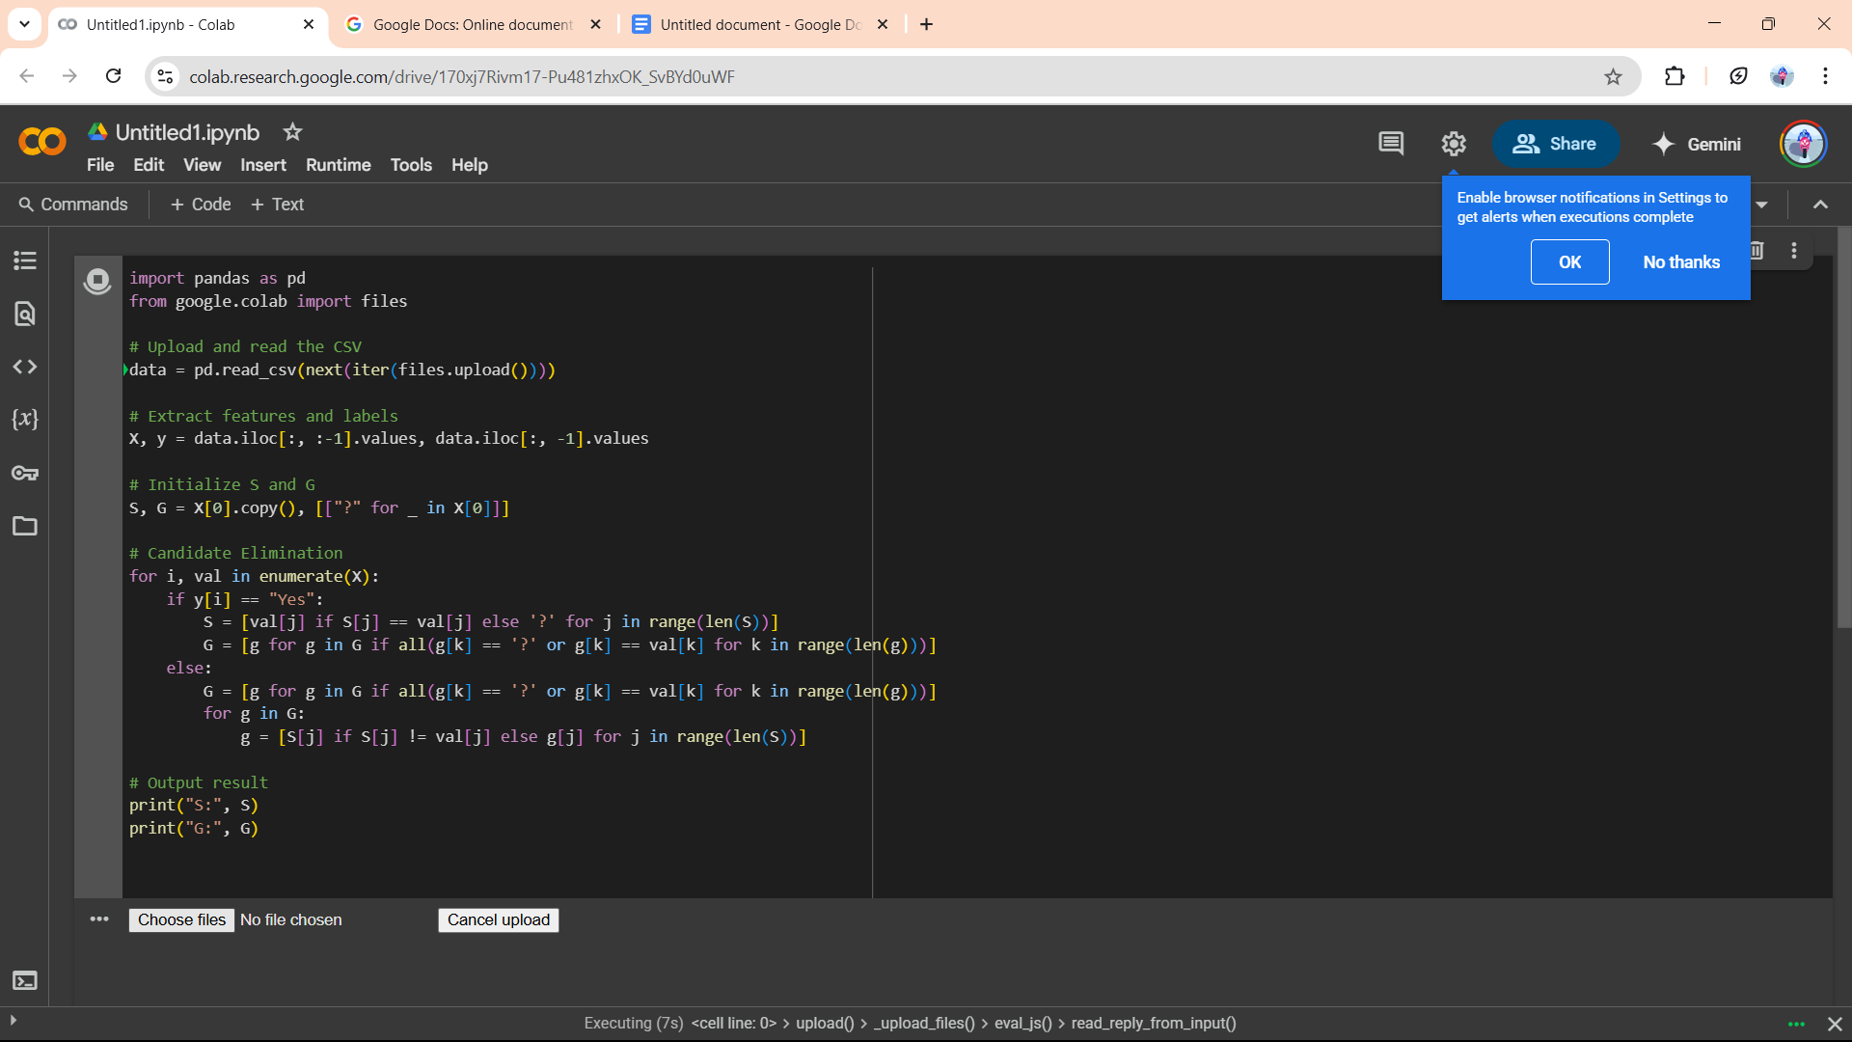
Step 2: Create a Csv file


Step 3:input the csv file in the choose file option

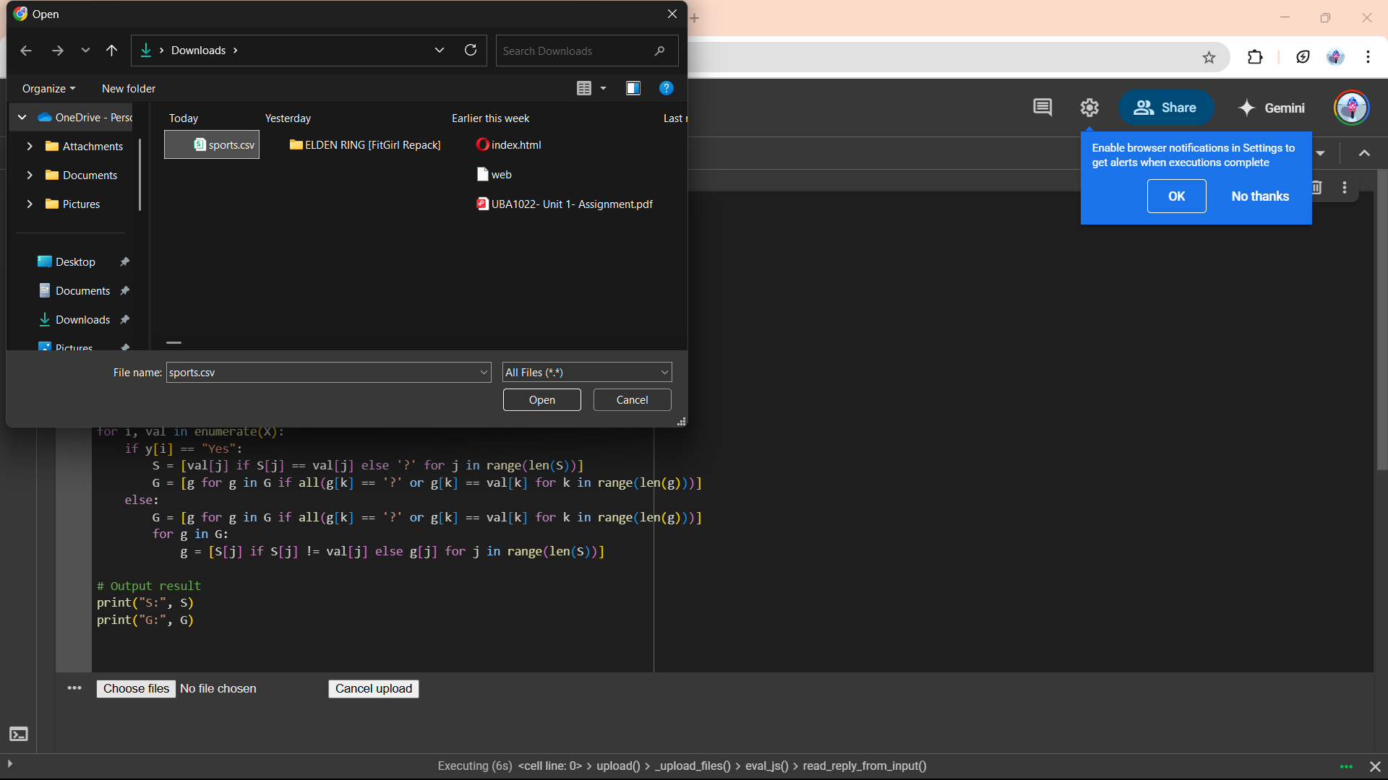

Step 4: Run the program and u will get the output
